RGB Animation Laser
User Manual

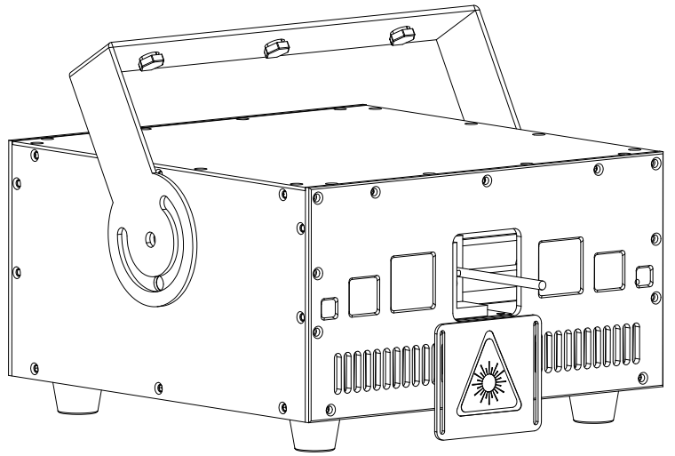

Please read this manual carefully before use!

Contents

Introduction--------------------------------------------------------------------------------------------P2

Silkscreen on product------------------------------------------------------------------------------P3

Safety instruction/Installation/Technical specification----------------------------------P4

Rear Panel/MENU-----------------------------------------------------------------------------------P5-6

DMX512 Channel-----------------------------------------------------------------------------------P7-10

DMX512 connection/DMX address setting---------------------------------------------------P11

Ringing------------------------------------------------------------------------------------------------- P12

Cleaning and maintenance/Warning/Warranty card------------------------------------P13

Introduction
Thank you for purchasing this product. To optimize the performance of this product,prior to use,please read these operating instructions carefully to familiarize yourself with the basic operation of this unit.Please keep the manual in safe price for future reference.
This unit has been tested at our factory before being shipped to you, there is no assembly required.
Once after received this product , please take and put carefully. And check cautiously that whether the product was damaged or not during the transportation.

Checking Parts
Please check if the following parts are included:
1 x Laser light
1 x User manual
1 x Power cable

Caution



CAUTION!

Keep this device away from rain and moisture!

Unplug mains lead before opening the housing!

Warning!


Damages caused by the disregard of this user manual are not subject to warranty. The dealer will not accept liability for any resulting defects or problems.

Symbol Instruction On The Device

…


---------------------------------------------------------------------------CE Certificate
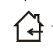

---------------------------------------------------------------------Only indoor use


----------------------------------------------------------------Environmental protection


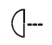
----------------------------------------The minimum distance from lighted objects(meter)

------------------------------------------------------Max. Ambient Temp


----------------------------------------------------Max. Housing Temp


---------------------------------------------------------------- Safety caution

Safety Instructions
- Please open and check whether break or not for transport once receive this fixture, if yes, not use it and contact dealer or manufacture as soon as possible.
- The Max applicable temperature for the light is 40°C. Do not use the light under or above the temperature. ta=40℃
- The fixture is applicable for many occasions, it should keep clean, and avoid long use in overheating or dusty environment. To prevent the fixture from the chemical liquid .
- User must be careful of fire, heat, electric and fall-off that make heavy or fatal injury. Please read this user manual carefully before power on and installation, following safety and operation instruction in it. If still have any questions, please contact dealer or manufacture.
- User must following this user manual, do not open fixture by yourself, if any problems, please contact professional technician, maintenance should by technician.
Do not power on or start the fixture before installation, please stop after working more than 8 hours, which will longer use life.
- Fixed installation, do not by strong shocks.
- The minimum distance between light and the illuminated surface must be more than 1 meter.
- Never look directly into the light source to avoid hurt to eyes (especially epileptics)!
When dustproof glass at light output breaks, cracks or other visible damage, user should replace with new glass to continue to use.

Installation
- When install this equipment please make sure there's no flammable surfaces (decorated things, etc) and minimum distance of 0.5M from the equipment to the flammable.
- The installation of the effect has to be built and constructed in a way that it can hold 10 times the weight and without any harming deformation.
- The installation must always be secured with a secondary safety attachment, e.g. an appropriate safety rope.Never stand directly below the device when mounting, removing or servicing the fixture.

Technical Specifications
Input voltage: AC100-240V, 50/60Hz
Fuse: BGDP ￠5x20mm 250VAC T5A
Total power:64W
Light source: 10W RGB semi-conductor integrated laser
Modulation: Analog
Control mode: Auto/Sound/DMX512/ILDA/Master-slave
Channels：17CH/21CH
Built-in static patterns: 200 pcs
Built-in dynamic patterns: 120 pcs
Scanning system: 20Kpps Scanner
Beam angle:±30º
Surface temp: Tb=45ºC ( this data testing when the environment temp is 30ºC)
Working temp: 10ºC--65ºC
Size:280*320*220 MM

Rear panel

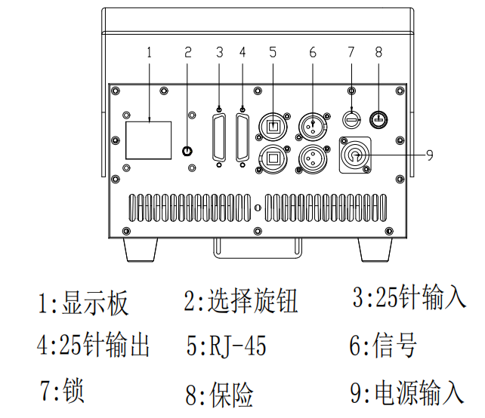
1: display | 2: knob | 3: 25-pin ILDA input
4: 25-pin ILDA output | 5: ILDA-RJ45 | 6: DMX signal input / output
7: key switch | 8: fuse | 9.power input

1. MENU operation

Rotate the knob at display’s right side to operate the menu, press knob to enter sub-menu or exit menu, after operation, double-click the knob to save the option and exit the menu.(Eg: when setting DMX address should Non-stop Double click the knob and exit MENU, then DMX address can successed save)

2.MENU display
1 | DMX ADDR | 1-512 | language setting
2 | CHANNEL | 17CH/21CH | 17CH/21CH
3 | MODE |  | 1 AUTO
3 | MODE |  | 2 SOUND
3 | MODE |  | 3 Built-in FLASH animation effect
3 | MODE |  | 4 ILDA mode, PC control
3 | MODE |  | 5 Aurora built-in program
3 | MODE |  | 6 Wormhole - Time Tunnel Built-in Program
3 | MODE |  | 7 Landmark built-in program
3 | MODE |  | 8 Lights turn off and stand by
3 | MODE |  | 9 Slave mode
4 | SPEED | 0-100 | Auto Speed
5 | SIZE | 1-100 | Pattern size
6 | PHASE XY | X+/Y+ | Pattern phase
7 | DIM R | 0-100 | Red brightness adjustment
8 | DIM G | 0-100 | Green brightness adjustment
9 | DIM B | 0-100 | Blue brightness adjustment
10 | MODULATION | TTL/ANALOG | Modulation
11 | LANGUAGE | CN/EN | language setting
12 | Software version | VER1.X | current software version Ver1.X

DMX Channel Instructions

1.17CH Mode

 |  | Value | Function
CH1 | Dimming | 0-255 | Dimming
CH2 | Strobe | 0-9 | No strobe
CH2 | Strobe | 10-255 | strobe from slow to fast
CH3 | Color | 0-35 | white-red-blue-pink-cyan-yellow-green (fixed color selection)
CH3 | Color | 36-39 | overall color change (flow speed is controlled by CH4)
CH3 | Color | 40-44 | default color
CH3 | Color | 45-48 | colorful colors
CH3 | Color | 49-64 | 2-segment color selection 4 numerical steps
CH3 | Color | 65-84 | 3-segment color selection 4 numerical steps
CH3 | Color | 85-100 | 4-segment color selection 4 numerical steps
CH3 | Color | 101-116 | 8-segment color selection 4 numerical steps
CH3 | Color | 117-164 | 16-segment color selection 4 numerical steps
CH3 | Color | 165-212 | 32-segment color selection 4 numerical steps
CH3 | Color | 213-219 | Color dynamic flow 1
CH3 | Color | 220-226 | Color dynamic flow 2
CH3 | Color | 227-233 | Color dynamic flow 3
CH3 | Color | 234-240 | Color dynamic flow 4
CH3 | Color | 241-247 | Color dynamic flow 5
CH3 | Color | 248-255 | Color dynamic flow 6
CH4 | color flow speed | 0-9 | No color flowing
CH4 | color flow speed | 10-127 | color flowing forward, the speed is from slow to fast
CH4 | color flow speed | 128-255 | color flowing reverse, the speed is from slow to fast
CH5 | pattern selection | 0-255 | pattern selection (pattern grouping is controlled by CH6)
CH6 | Pattern group selection | 0-24 | Built-in group 1
CH6 | Pattern group selection | 25-49 | Built-in group 2
CH6 | Pattern group selection | 50-74 | Built-in group 3
CH6 | Pattern group selection | 75-99 | Built-in group 4
CH6 | Pattern group selection | 100-124 | Built-in group 5
CH6 | Pattern group selection | 125-149 | ILDA animation group 1
CH6 | Pattern group selection | 150-174 | ILDA animation group 2
CH6 | Pattern group selection | 175-199 | ILDA animation group 3
CH6 | Pattern group selection | 200-224 | ILDA animation group 4
CH6 | Pattern group selection | 225-255 | ILDA animation group 5
CH7 | Pattern size | 0-255 | Pattern size manual selection
CH8 | Pattern zoom | 0-15 | Pattern size selection
CH8 | Pattern zoom | 16-55 | Speed option for pattern small to large
CH8 | Pattern zoom | 56-95 | Speed option for pattern large to small
CH8 | Pattern zoom | 96-135 | Zoom speed selection
CH8 | Pattern zoom | 136-175 | 2-segment irregular cyclic zoom
CH8 | Pattern zoom | 176-215 | 3-segment irregular cyclic zoom
CH8 | Pattern zoom | 216-255 | 4-segment irregular cyclic zoom
CH9 | Pattern rotation around the center | 0-127 | Rotation angle option
CH9 | Pattern rotation around the center | 128-191 | Forward rotation speed option
CH9 | Pattern rotation around the center | 192-255 | Reverse rotation speed option
CH10 | Pattern rotation around the X-axis | 0-127 | Pan rotation position option
CH10 | Pattern rotation around the X-axis | 128-255 | Pan rotation speed option
CH11 | Pattern rotation around the Y-axis | 0-127 | Tilt rotation position option
CH11 | Pattern rotation around the Y-axis | 128-255 | Tilt rotation speed option
CH12 | Pan move | 0-127 | Pan position option
CH12 | Pan move | 128-255 | Pan move speed from slow to fast
CH13 | Tilt move | 0-127 | Tilt position option
CH13 | Tilt move | 128-255 | Tilt move speed from slow to fast
CH14 | X direction wave | 0-9 | No wave
CH14 | X direction wave | 10-255 | Wave range and speed adjustment (range from small to large, speed from slow to fast)
CH15 | Y direction wave | 0-9 | No wave
CH15 | Y direction wave | 10-255 | Wave range and speed adjustment (range from small to large, speed from slow to fast)
CH16 | Built-in dynamic effect | 0-1 | No effect
CH16 | Built-in dynamic effect | 2-253 | Built-in effect selection, speed and color controlled by CH17
CH16 | Built-in dynamic effect | 254-255 | All effects randomly auto
CH17 | Built-in dynamic effect Speed | 0-127 | Built-in effect speed from fast to slow, color program built-in curing
CH17 | Built-in dynamic effect Speed | 128-255 | Built-in effect speed from fast to slow,color controlled by console

2.21CH Mode

 |  | Value | Function
CH1 | Dimming | 0-255 | Total Dimming
CH2 | R dimming | 0-255 | Red linear dimming
CH3 | G dimming | 0-255 | Green linear dimming
CH4 | B dimming | 0-255 | Blue linear dimming
CH5 | Strobe | 0-9 | No strobe
CH5 | Strobe | 10-255 | strobe from slow to fast
CH6 | Color | 0-35 | white-red-blue-pink-cyan-yellow-green (fixed color selection)
CH6 | Color | 36-39 | overall color change (flow speed is controlled by CH7)
CH6 | Color | 40-44 | default color
CH6 | Color | 45-48 | colorful colors
CH6 | Color | 49-64 | 2-segment color selection 4 numerical steps
CH6 | Color | 65-84 | 3-segment color selection 4 numerical steps
CH6 | Color | 85-100 | 4-segment color selection 4 numerical steps
CH6 | Color | 101-116 | 8-segment color selection 4 numerical steps
CH6 | Color | 117-164 | 16-segment color selection 4 numerical steps
CH6 | Color | 165-212 | 32-segment color selection 4 numerical steps
CH6 | Color | 213-219 | Color dynamic flow 1
CH6 | Color | 220-226 | Color dynamic flow 2
CH6 | Color | 227-233 | Color dynamic flow 3
CH6 | Color | 234-240 | Color dynamic flow 4
CH6 | Color | 241-247 | Color dynamic flow 5
CH6 | Color | 248-255 | Color dynamic flow 6
CH7 | color flow speed | 0-9 | No color flowing
CH7 | color flow speed | 10-127 | color flowing forward, the speed is from slow to fast
CH7 | color flow speed | 128-255 | color flowing reverse, the speed is from slow to fast
CH8 | pattern selection | 0-255 | pattern selection (pattern grouping is controlled by CH9)
CH9 | Pattern group selection | 0-24 | Built-in group 1
CH9 | Pattern group selection | 25-49 | Built-in group 2
CH9 | Pattern group selection | 50-74 | Built-in group 3
CH9 | Pattern group selection | 75-99 | Built-in group 4
CH9 | Pattern group selection | 100-124 | Built-in group 5
CH9 | Pattern group selection | 125-149 | ILDA animation group 1
CH9 | Pattern group selection | 150-174 | ILDA animation group 2
CH9 | Pattern group selection | 175-199 | ILDA animation group 3
CH9 | Pattern group selection | 200-224 | ILDA animation group 4
CH9 | Pattern group selection | 225-255 | ILDA animation group 5
CH10 | Pattern size | 0-255 | Pattern size manual selection
CH11 | Pattern zoom | 0-15 | Pattern size selection
CH11 | Pattern zoom | 16-55 | Speed option for pattern small to large
CH11 | Pattern zoom | 56-95 | Speed option for pattern large to small
CH11 | Pattern zoom | 96-135 | Zoom speed selection
CH11 | Pattern zoom | 136-175 | 2-segment irregular cyclic zoom
CH11 | Pattern zoom | 176-215 | 3-segment irregular cyclic zoom
CH11 | Pattern zoom | 216-255 | 4-segment irregular cyclic zoom
CH12 | Pattern rotation around the center | 0-127 | Rotation angle option
CH12 | Pattern rotation around the center | 128-191 | Forward rotation speed option
CH12 | Pattern rotation around the center | 192-255 | Reverse rotation speed option
CH13 | Pattern rotation around the X-axis | 0-127 | Pan rotation position option
CH13 | Pattern rotation around the X-axis | 128-255 | Pan rotation speed option
CH14 | Pattern rotation around the Y-axis | 0-127 | Tilt rotation position option
CH14 | Pattern rotation around the Y-axis | 128-255 | Tilt rotation speed option
CH15 | Pan move | 0-127 | Pan position option
CH15 | Pan move | 128-255 | Pan move speed from slow to fast
CH16 | Tilt move | 0-127 | Tilt position option
CH16 | Tilt move | 128-255 | Tilt move speed from slow to fast
CH17 | X direction wave | 0-9 | No wave
CH17 | X direction wave | 10-255 | Wave range and speed adjustment (range from small to large, speed from slow to fast)
CH18 | Y direction wave | 0-9 | No wave
CH18 | Y direction wave | 10-255 | Wave range and speed adjustment (range from small to large, speed from slow to fast)
CH19 | Pattern drawing | 0-1 | no drawing
CH19 | Pattern drawing | 2-63 | Manual gradual drawing 1
CH19 | Pattern drawing | 64-127 | Manual gradual drawing 2
CH19 | Pattern drawing | 128-153 | Automatic gradual drawing (increase)
CH19 | Pattern drawing | 154-179 | Automatic gradual drawing (decrease)
CH19 | Pattern drawing | 180-205 | Automatic gradual drawing (increase first and then decrease - reverse)
CH19 | Pattern drawing | 206-255 | Automatic gradual drawing (increase first and then decrease - forward)
CH20 | Built-in dynamic effect | 0-1 | No effect
CH20 | Built-in dynamic effect | 2-253 | Built-in effect selection, speed and color controlled by CH21
CH20 | Built-in dynamic effect | 254-255 | All effects randomly auto
CH21 | Built-in dynamic effect Speed | 0-127 | Built-in effect speed from fast to slow, color program built-in curing
CH21 | Built-in dynamic effect Speed | 128-255 | Built-in effect speed from fast to slow,color controlled by console

DMX-512 connection
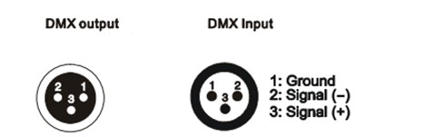
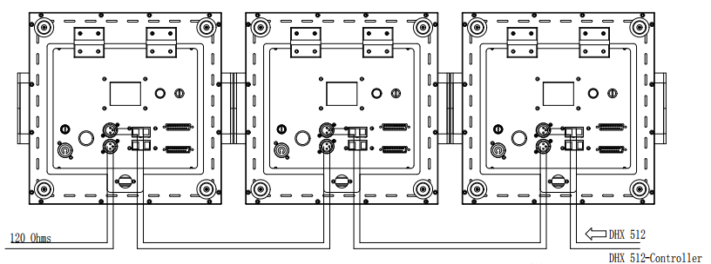
DMX In To the Fourth
First light (Address 001) Second light (Address 018) Third light(Address 035)

DMX Address setting
Each fixture must set a specific starting address. When receiving signal transmission, fixture will receive channel control signals which from the starting address.
According to different requirements or easy to use, the user can set many value fixtures to the same address, also can set up a separate address for every device.
If you set the same address,all the devices will receive from DMX channels signal. All connecting fixtures are jointly controlled, controller can't separate control a device.
If you set a different address, each device will be separate from its particular set the starting address and begin accepting DMX512 control signal, so that more convenient separate control one device. Using this method must be based on channel quantity of device to determine a starting address.
This laser light has 17 channels.you should set the starting address of the first unit to 1, the second unit to 18(1 + 17), the third unit to 35 (17*2+ 1), and so on.

Ringing
1 . Mounting bracket
2 . Handle
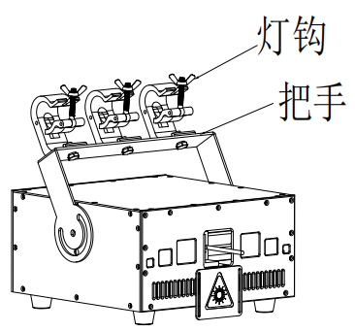
Bracket
Handle

- .The ambient temperature range is 1°C--45°C, must never be exceeded.
- .The installation of the projector has to be built and constructed in a way that it can hold 10 times the weight for 1 hour without any harming deformation.
- ).When rigging or servicing the fixture staying in the area below the installation place, on bridges,under high working places and other endangered areas is forbidden.
D).The operator has to make sure that safety-relating and machine-technical installations are approved by an expert before taking into operation for the first time and after changes before taking into operation another time.
E).The operator has to make sure that safety-relating and machine-technical installations are approved by a skilled person once a year.
F). Sure M8 screws on mounting bracket fixed middle hole ¢12.5mm of handle

Cleaning and maintenance

Maintenance should be performed every 15-day period, by using a sponge which is dipped with alcohol, rather than wet cloth or other chemical liquid, to clean the mirror.

Always disconnect from the mains when the device is not in use or before cleaning it.

Caution
Make sure power off before cleaning and maintenance!

Warning

Warning!
Never look directly into the light source,as sensitive persons may suffer an epileptic shock(especially meant for epileptics)!
Caution

Warning!
Any power connected must by professional person


Warranty Card
This product is made of high-brightness transistor. We will provide 1 year warranty under the condition that user has operated the light normally and lifetime service. We won't provide warranty if the damage is caused by artificial or force majeure event. Cost of fittings should be charged by user if product need maintenance after 1 year .Please cut this warranty card and shipped it along with the product to our factory when applying for warranty.
Product：
Purchasing date：
Code of invoice：
Warranty date: From To
User’s name： Add：
Company： Tel：

